**IST 659 LAB Assignment 2**

**Problem 1:** You are asked to design a database for an online learning website. Using this website, a student may take as many online courses as he/she wants. An online course may be taken by any number of students. Each student must rate the course that he/she takes using a like-scale from 1 to 5. Thus, the *popularity* of a course is calculated based on the average scores rated by the students.

1. **ERD**

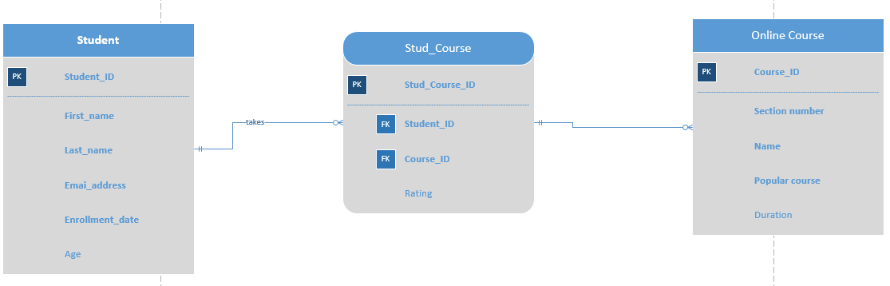

1. **Datasheet View of each table**
2. Student Table

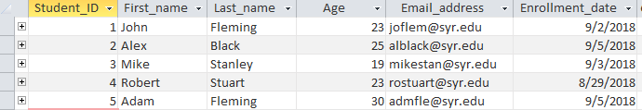

1. Online Course Table

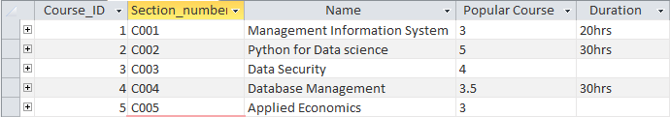

1. Stud Course Table

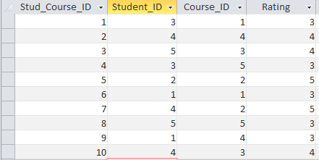

1. Data relationship model in Access

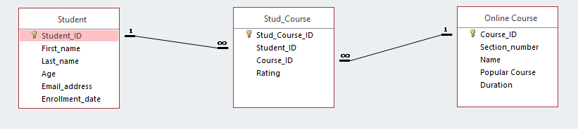

1. **Assumption:**

Popularity of the course is calculated based on the average values of the course rating. For simplicity of the scenario it was entered manually.

Student (Student_ID, First_name, Last_name, Email_address, Enrollment_date),

Online Course (Course_ID, Section_number, Name, Popular course, Duration), Stud_Course (Stud_Course_ID, Student_ID, Course_ID, Rating) are all required attributes.

**Problem 2:** Below is an example of a ternary relationship: Doctor prescribes medicines for patients. Please create a different ternary relationship on your own, model it, and create the database tables.

1. **Business Rules**

* Each Supplier can supply as many number of cars and each car can be supplied by as many number of suppliers.
* Each Supplier can supply as many number of parts and each part can be supplied by as many number of suppliers.

1. **ERD**

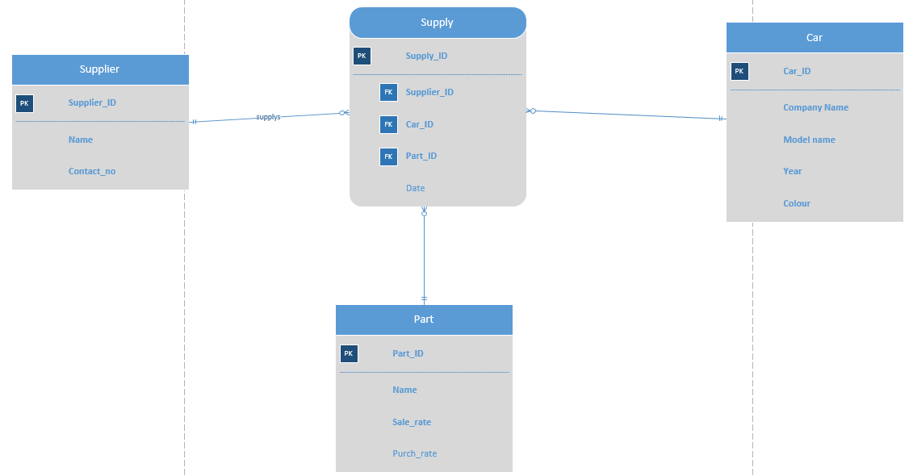

1. **Datasheet view of each table**
2. Supplier table

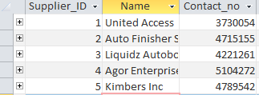

1. Car table

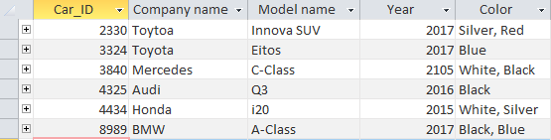

1. Part table

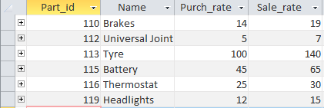

1. Supply

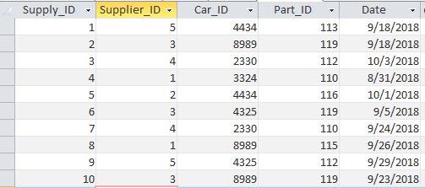

1. Data relationship in Access

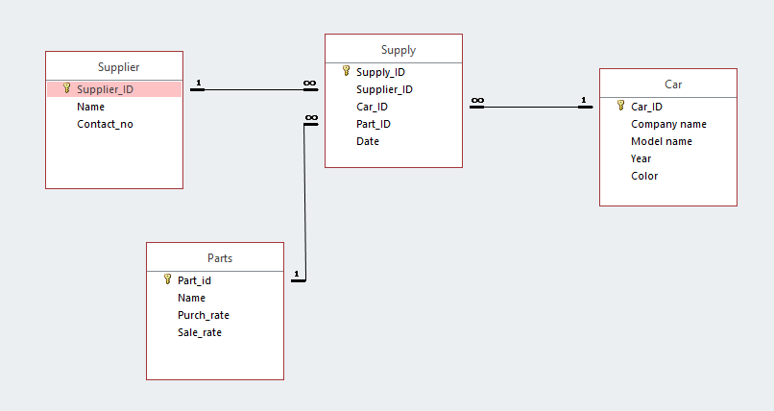

1. **Assumption:**

Supplier (Supplier_ID, Name, Contact_no)

Car (Car_ID, Company name, Model name, Year, Color)

Supply (Supply_ID, Supplier_ID, Car_ID, Part_ID, Date)

Part (Part_ID, Name, Sale_rate) are all required attributes.